# Strategy

## Definition

**# Source**: **Chatgpt (GPT-5-Standard) at [8/25/2025]**

**Strategy (as a video game genre)** is a type of game where **the main focus is on planning, tactics, and decision-making** rather than fast reflexes or action. Players must think ahead and manage resources, units, or territories to achieve victory.

## Key Features of Strategy Games

**# Source**: **Chatgpt (GPT-5-Standard) at [8/25/2025]**

* Emphasize **thinking over reacting**.
* Require **resource management**, **long-term planning**, and **tactical moves**.
* Often involve **controlling multiple units or systems**.

## Main Subgenres of Strategy Games

**# Source**: **Chatgpt (GPT-5-Standard) at [8/25/2025]**

1. **Real-Time Strategy (RTS)**
   * **Description:** Base building, resource gathering, and army control in real time.
   * **Examples:** *StarCraft II*, *Age of Empires II*.
2. **Turn-Based Strategy (TBS)**
   * **Description:** Players take turns to plan and act, focusing on large-scale empire or army control.
   * **Examples:** *Civilization VI*, *Advance Wars*.
3. **Real-Time Tactics (RTT)**
   * **Description:** Tactical combat in real time; no base building or economy.
   * **Examples:** *Commandos: Behind Enemy Lines*, *Desperados III*.
4. **Turn-Based Tactics (TBT)**
   * **Description:** Tactical combat in turns; squad-level control, positioning, and cover are key.
   * **Examples:** *XCOM: Enemy Unknown*, *Fire Emblem*, *Gears Tactics*.
5. **Grand Strategy**
   * **Description:** Large-scale control of nations or empires: politics, diplomacy, warfare.
   * **Examples:** *Hearts of Iron IV*, *Europa Universalis IV*.
6. **4X Strategy**
   * **Description:** Explore, Expand, Exploit, Exterminate; deep empire-building and conquest.
   * **Examples:** *Sid Meier’s Civilization*, *Stellaris*.
7. **Tower Defense**
   * **Description:** Protect a base by strategically placing defenses against waves of enemies.
   * **Examples:** *Plants vs Zombies*, *Bloons TD 6*.
8. **MOBA (Multiplayer Online Battle Arena)**
   * **Description:** Real-time team battles controlling single heroes with strategic coordination.
   * **Examples:** *League of Legends*, *Dota 2*.
9. **Auto Battler (Auto Chess)**
   * **Description:** Place units strategically; battles play out automatically.
   * **Examples:** *Teamfight Tactics*, *Dota Underlords*.
10. **Card-Based Strategy**
    * **Description:** Deck-building and card mechanics as the main strategic element.
    * **Examples:** *Hearthstone*, *Slay the Spire*.
11. **Wargames**
    * **Description:** Military-focused strategy, often historical with tactical combat scenarios.
    * **Examples:** *Total War series* (mix of RTS and TBS), *Panzer Corps*.

✅ **Core Idea:** Success depends on **strategy, resource allocation, and foresight**, not just quick reactions.

## comparison between Real-Time Strategy (RTS) and Turn-Based Strategy (TBS)

**# Source**: **Chatgpt (GPT-5-Standard) at [8/25/2025]**

Here’s a clear comparison between **Real-Time Strategy (RTS)** and **Turn-Based Strategy (TBS):**

**✅ Real-Time Strategy (RTS)**

* **Definition:** A strategy game where actions happen continuously, and players must make decisions in real time.
* **Gameplay Focus:**
  + **Base building**
  + **Resource gathering**
  + **Army production and control**
  + **Fast-paced decisions under time pressure**
* **Player Interaction:** Simultaneous – both players act at the same time.
* **Examples:**
  + *StarCraft II*
  + *Age of Empires II*
  + *Warcraft III*

**✅ Turn-Based Strategy (TBS)**

* **Definition:** A strategy game where players take turns, allowing for careful planning without time pressure.
* **Gameplay Focus:**
  + **Territory control**
  + **Long-term planning**
  + **Movement in discrete steps (tiles or grids)**
* **Player Interaction:** Sequential – one player moves, then the other.
* **Examples:**
  + *Civilization VI*
  + *Advance Wars*
  + *XCOM: Enemy Unknown* (although this is more tactical than pure strategy)

**✅ Key Differences**

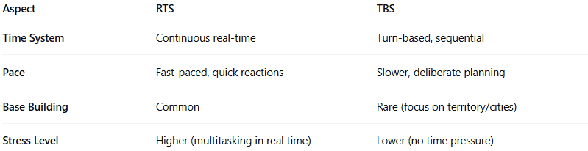

| **Aspect** | **RTS** | **TBS** |
| --- | --- | --- |
| **Time System** | Continuous real-time | Turn-based, sequential |
| **Pace** | Fast-paced, quick reactions | Slower, deliberate planning |
| **Base Building** | Common | Rare (focus on territory/cities) |
| **Stress Level** | Higher (multitasking in real time) | Lower (no time pressure) |

✅ **Summary:**

* **RTS** = Real-time, multitasking, economy + combat.
* **TBS** = Turn-based, deep planning, no time pressure.

## comparison between RTS vs TBS vs RTT vs TBT

**# Source**: **Chatgpt (GPT-5-Standard) at [8/25/2025]**

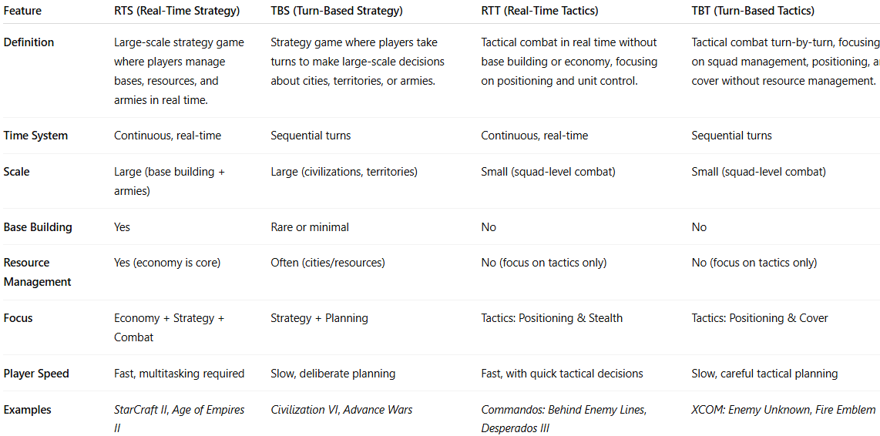

| **Feature** | **RTS (Real-Time Strategy)** | **TBS (Turn-Based Strategy)** | **RTT (Real-Time Tactics)** | **TBT (Turn-Based Tactics)** |
| --- | --- | --- | --- | --- |
| **Definition** | Large-scale strategy game where players manage bases, resources, and armies in real time. | Strategy game where players take turns to make large-scale decisions about cities, territories, or armies. | Tactical combat in real time without base building or economy, focusing on positioning and unit control. | Tactical combat turn-by-turn, focusing on squad management, positioning, and cover without resource management. |
| **Time System** | Continuous, real-time | Sequential turns | Continuous, real-time | Sequential turns |
| **Scale** | Large (base building + armies) | Large (civilizations, territories) | Small (squad-level combat) | Small (squad-level combat) |
| **Base Building** | Yes | Rare or minimal | No | No |
| **Resource Management** | Yes (economy is core) | Often (cities/resources) | No (focus on tactics only) | No (focus on tactics only) |
| **Focus** | Economy + Strategy + Combat | Strategy + Planning | Tactics: Positioning & Stealth | Tactics: Positioning & Cover |
| **Player Speed** | Fast, multitasking required | Slow, deliberate planning | Fast, with quick tactical decisions | Slow, careful tactical planning |
| **Examples** | *StarCraft II*, *Age of Empires II* | *Civilization VI*, *Advance Wars* | *Commandos: Behind Enemy Lines*, *Desperados III* | *XCOM: Enemy Unknown*, *Fire Emblem* |